]
Spanning Tree Protocol

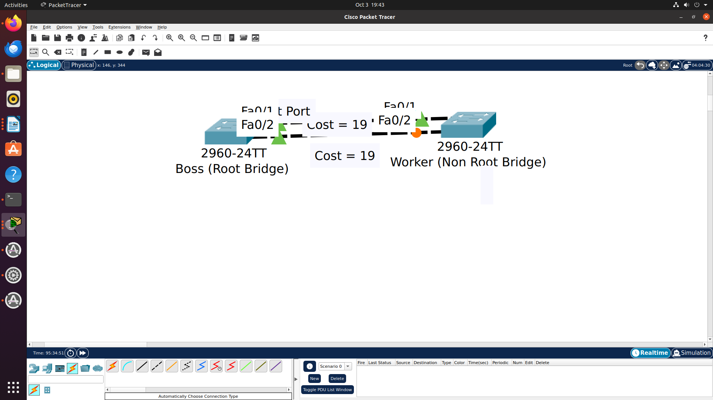

Command to change Priority of switch

sw1(config)#spanning-tree vlan 1 priority 4096

